UNIT 2 — MOTION IN TWO DIMENSIONS · TEACHER KEY  Vectors Quiz, Version A | U02 / S2.2  QUIZ · ANSWER KEY

1.
Restate 215° in two other ways.

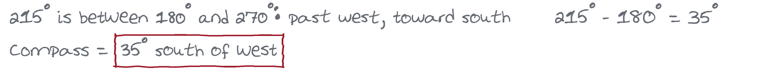
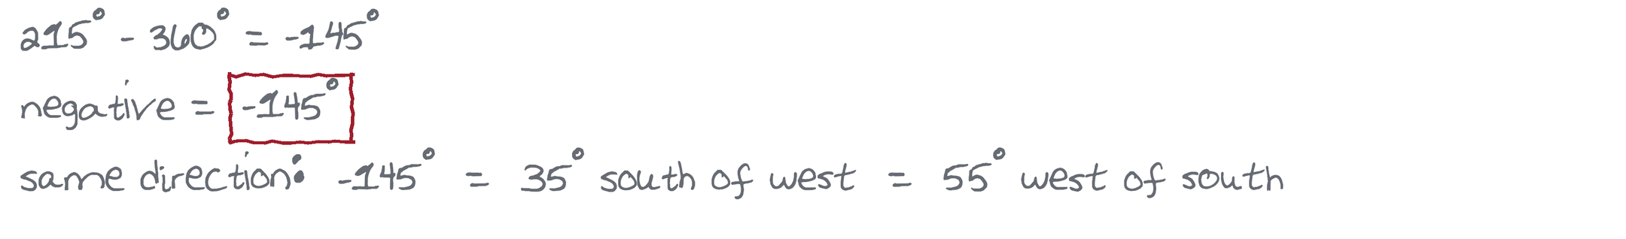

2.
Restate 40° north of west in two other ways.

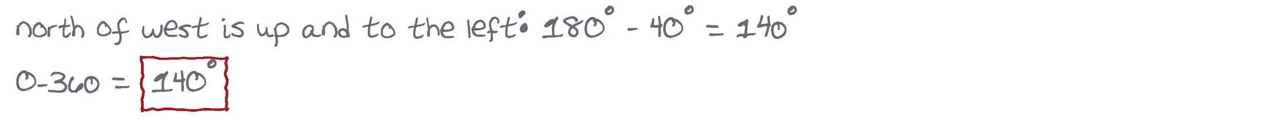
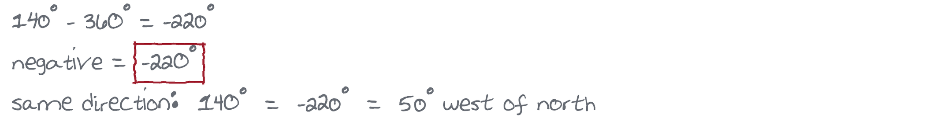

3.
Restate −70° in two other ways.

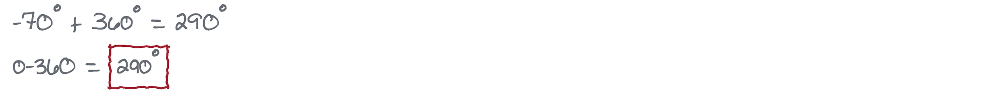
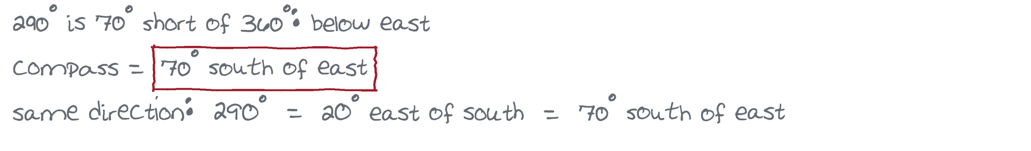

4.
Pac-Man travels 45 m north and then 28 m west through the maze. Find his resultant displacement: magnitude and direction.

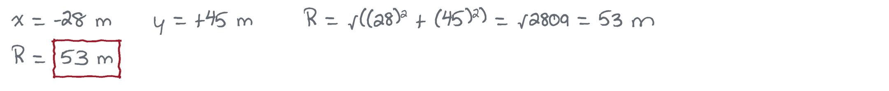
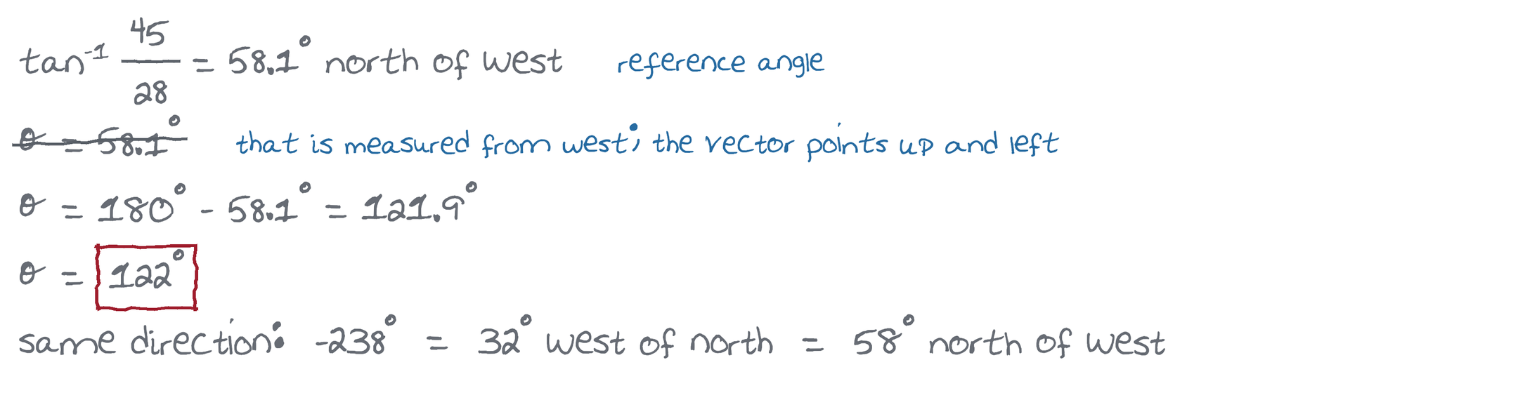

5.
Sam Wilson flies the Falcon at 240 km/h at 40° north of east. A wind blowing toward 30° south of east at 65 km/h also acts on him. Find his resultant velocity: magnitude and direction.



